Manning Boost V1.0

GJCAMANN © 2014

The Manning Boost is a multi-use booster pedal. Depending on how this is populated it can be built as a MOSFET boost, SHO, LPB1 and many others including several Lovetone style pedals. I’m not including schematics of specific pedals to respect the work of others.

There are some special taps on this board to make it even more useful:

BUF – this is a non-inverted buffered unity gain output. But I forgot the output capacitor on this version, so be sure to include on off board on this version.

CLIP – this is a tap that can be brought to some offboard clippers to create an electra style OD. (see my ClipperSwitch board or DoubleClipperSwitch board). Alternately, the on-board volume pot can be omitted and the CLIP output can be brought to an off-board pot.

Biasing the Tranny: Several schemes are presented.

* You can use R1 and R2 to create a voltage divider with R3 being a resistor (as in the AMZ Mosfet Booster) or a jumper (as in the LPB1).
* Omit R1. Jumper R3 and use R2 and Rfb to self-bias (as in the SHO or Super 6).

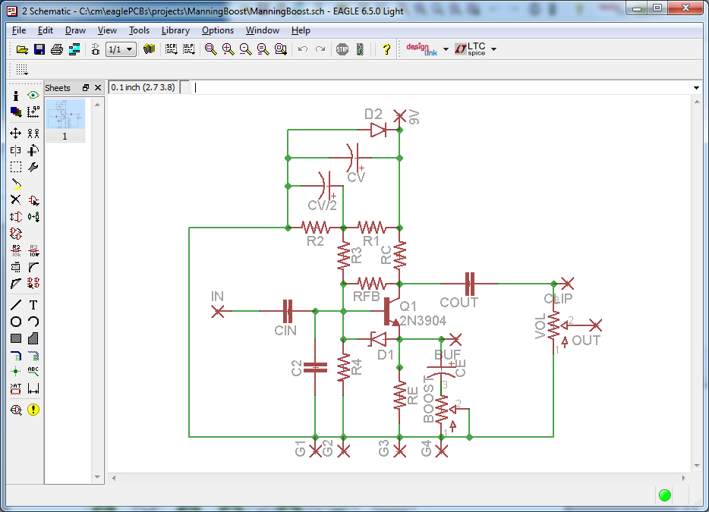

Some pedals that can be built using this:

Mosfet boost, SHO, Super Duper, Lovepedal Woodrow, COT 50 (almost), Englishman (almost), Super 6 (with offboard parts), Les Luis (nearly), Landgraff boost (almost), Delux Sixty, Vox Treble Booster, Naga Viper (almost – sub RFB w/ CAP). All product names are trademarks of their respective owners.

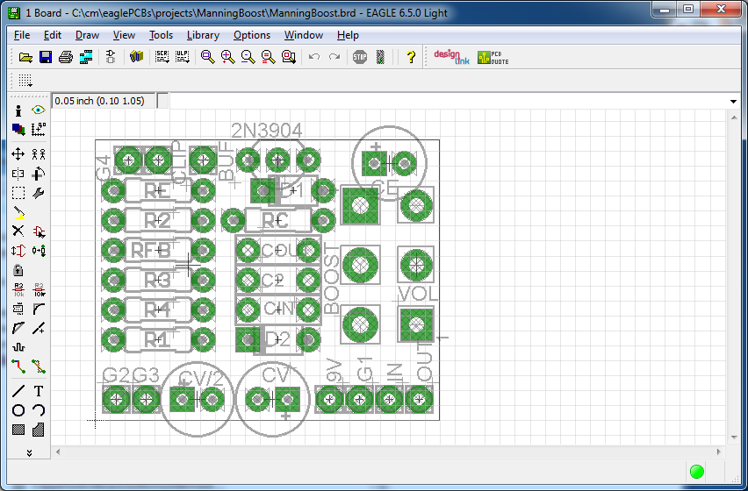

Here are some upgrades for the next version. Other comments are welcome.

TODO:

Put switch in series with BOOST pot.

Add anti-pip resistors Rin and Rout.

Add a input resistor in series with CIN?

Remove R4 – it is redundant with R2.

Change connection order to IN/G/9V/OUT

THERE IS NO WARRANTY FOR THIS DESIGN, TO THE EXTENT PERMITTED BY APPLICABLE LAW. THE DESIGN IS PROVIDED “AS IS” WITHOUT WARRANTY OF ANY KIND, EITHER EXPRESSED OR IMPLIED, INCLUDING, BUT NOT LIMITED TO, THE IMPLIED WARRANTIES OF MERCHANTABILITY AND FITNESS FOR A PARTICULAR PURPOSE. THE ENTIRE RISK AS TO THE QUALITY AND PERFORMANCE OF THE DESIGN IS WITH YOU. SHOULD THE DESIGN PROVE DEFECTIVE, YOU ASSUME THE COST OF ALL NECESSARY SERVICING, REPAIR OR CORRECTION.

Licensed under <http://creativecommons.org/licenses/by-sa/4.0/deed.en_US>